SKILL WEEK-4
Task 1:
To Split Input into Tokens, Identify Delimiters, Handle Whitespace, Create Token Structures, Validate Token Streams, Debug Parsing Output and Design Parser Logic, Generate Parse Trees, Validate Syntax, Detect Errors, Handle Empty Commands, Produce Execution Structures
CODE:
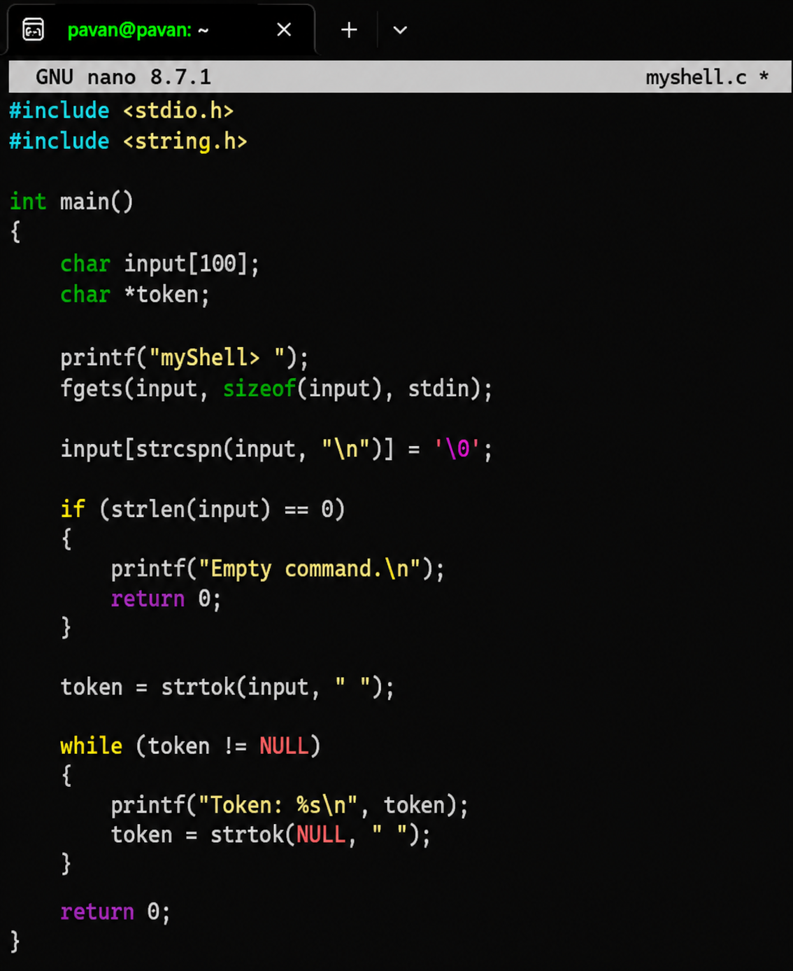
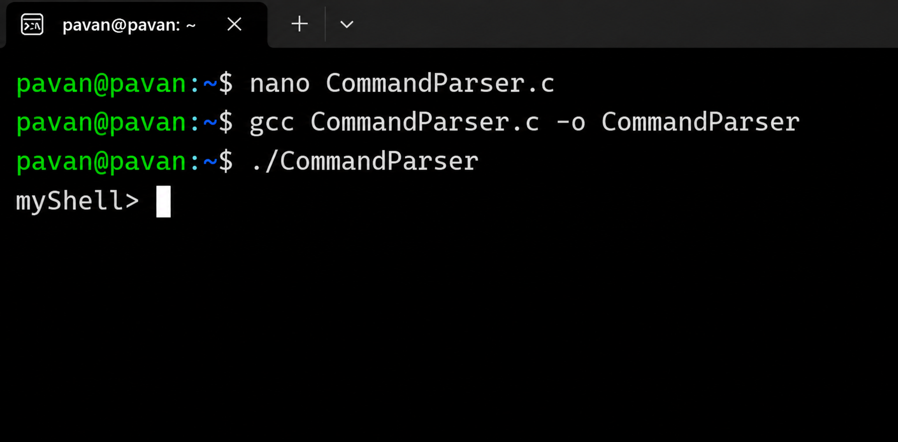
REPORT: The input was successfully divided into individual tokens using delimiters such as spaces and tabs. The program correctly displayed each argument separately and handled empty commands. Thus, the basic tokenization and parsing functionality required for the shell was successfully implemented
Task 2: To Apply Single Quotes, Preserve Literal Content, Ignore Variable Expansion, Store Quoted Strings, Validate Parsing Results, Test Edge Cases
